Base window and attempting to trim a blank file path.  
  
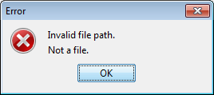

Attempting to trim a directory.  
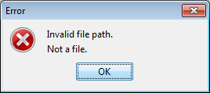

Attempting to trim a bad file path.  
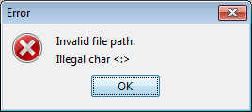

Attempting to trim a non-existent file.  
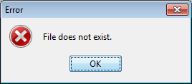

Loading test file to trim.  
Contents of test file.  
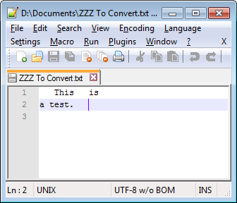  
Results of attempting to trim file.  
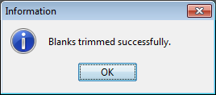  
Contents of test file after trimming.  
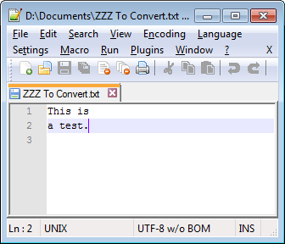

Loading blank test file to trim.  
Contents of test file.  
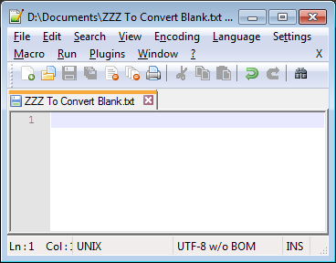  
Results of attempting to trim file.  
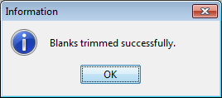  
Contents of test file after trimming. (No change.)  
